|  |
| --- |
|  |
| C:\Users\02993\Pictures\Pictures requested by Swazi Maja\YPs (2).jpg | **Infrastructure Delivery Division**  **2016/2017 ANNUAL BEPP EVALUATION REPORT**  **Prepared for:**  **National Treasury – Cities Support Programme (CSP)**  Prepared by:  Development Bank of Southern Africa (DBSA)  Infrastructure Delivery Division  PO Box 1234  Halfway House  Midrand  1685  **July 2016** |
|  |  |
|  |  |
|  |  |
|  |  |
|  |  |

Control Sheet

**Title : BEPPS Financial Evaluation**

**Reference : DBSA**

**Revision No :**

**Date** :

Revision History

|  |  |  |  |
| --- | --- | --- | --- |
| **Version** | **Revision Date** | **Change Summary** | **Prepared by** |
|  |  |  |  |
|  |  |  |  |
|  |  |  |  |
|  |  |  |  |

Table of Contents

1. Introduction 4

i. Background 4

ii. Problem Statement 5

iii. Objectives 7

iv. Scope 8

v. Progressive model 9

2. Approach 11

3. Framework: Bankability and Finance-ability Criteria and Guidelines 12

3.1 Comprehensive Plans and Models 12

3.2 DFI Project Funding Criteria 13

3.3 National Treasury 2016/17 BEPP Guidelines 14

4. Evaluation and Recommendations 16

4.1. Consolidated Metro Capital Funding Requirements 16

4.1.1. Planned External Loans 18

4.2. Financial Status and Borrowing Capacity of Metropolitans 19

4.2.1. Credit Ratings 19

4.2.1.1.Evaluation of 2016/17 Credit Rating 21

4.2.2. Financial Ratios 22

4.2.2.1.Evaluation of 2016/17 Financial Ratios 23

4.2.3. Cash-generating Project Pipeline 25

4.2.3.1.Evaluation of 2016/17 Cash-generating Pipeline 26

4.2.4. Long-term Financial Strategy 28

4.2.4.1.Evaluation of 2016/17 Long-term Financial Strategy 29

4.2.5. Off-Balance Sheet Initiatives 31

4.2.5.1.Evaluation of 2016/17 Off-Balance Sheet Arrangements 32

4.3. Project Pipeline Funding 33

4.3.1. Development of a Comprehensive Funding Plan 33

4.3.2. Innovative Solutions to Funding Requirements 35

i. Private Sector Partnerships 35

ii. PPP Feasibility Study 36

iii. Advantages of the PPP Structure 38

4.3.2.1.Evaluation of 2016/17 Project Pipeline and Funding 40

4.4. Risks Identification and Mitigation 42

4.4.1.1.Evaluation of 2016/17 Risk Identification and Mitigation 45

5. Conclusion 47

### Introduction

### Background

The DBSA and the National Treasury entered into a three (3) year Service Level Agreement (SLA) in October 2014 to implement the CSP which is aimed at improving the capacity of metropolitan cities and the way they function so as to create more inclusive, productive, and sustainable cities. The objective of the CSP are as follows:

* To enable cities to play a leading role as drivers of economic growth
* To provide an arena for the coordination of policy, fiscal and implementation support measures for cities
* To strategically respond to demand for support from cities
* To provide an integrated package of implementation support to cities
* To ensure that cities are enabled and appropriately encouraged to improve the performance of their built environment through accompanying changes to the regulatory and fiscal environment in each sector.

In terms of the SLA, the DBSA has been mandated to fulfil the following objective:

**“*Conduct analytical review of the Cities Built Environment plan and recommend intervention strategies***”.

To this effect, the DBSA-IDD will conduct an annual technical desktop review of BEPPs to assess how effectively and efficiently BEPPs are financed at an institutional and programme/project pipeline level.

According to the 2016/2017 BEPP guidelines on Capital Funding: BEPPs should clearly articulate the long term financing need and strategy for spatial transformation. This financing strategy should be based on the plan for spatial transformation – the spatial targeting approach that results in the identification of urban networks, Integration Zones, areas where service backlogs need to be addressed, informal settlements, marginalised areas, and growth nodes for economic development. The long term financial strategy provides the framework for investment activities that relate specifically to the financing pf projects within Integration Zones.

National Treasury recommended that the DBSA should focus on conducting an evaluation of the financing strategies of the metros and confirm the availability of critical programmes and catalytic projects to determine whether the BEPP’s can reach financial closure**.**

### Problem Statement

The BEPP is a requirement of the DORA in respect of infrastructure grants related to the built environment of metropolitan municipalities. It remains one of the eligibility requirements for the Integrated City Development Grant (ICDG). The ICDG is an incentive grant that rewards the application of infrastructure grants, as part of the total capital budget, toward catalysing spatial transformation through a spatial targeting approach at a sub-metropolitan level.

The evaluation of the 2015/16 BEPPs have highlighted the following deficiencies and inconsistencies in the various the financing models and strategies of the metro BEPPs:

* **Limited Consideration of Alternate Funding Options**

BEPPs have largely been developed to support the following grant funding allocations:

* ICDG – Integrated City Development Grant;
* USDG – Urban Settlements Development Grant;
* HSDG – Human Settlements Development Grant;
* PTIG – Public Transport Infrastructure Grant;
* NDPG – Neighbourhood Development Partnership Grant; and
* INEP – Integrated National Electrification Grant.

Accordingly, BEPPs contain limited or no information on alternate funding options aside from grants and borrowings. Whilst some metros indicate that a portion of the funding requirements for catalytic projects will be provided for through internal funding, there is a general absence of designing innovative solutions to address this challenge.

* **Significant Dependence on Grant Funding**

Metros traditionally utilise three sources of funding being grant funding, borrowings; and internal funding (including own revenues and public contributions). As is evident from the graph below, 31% to 87% of capital projects are financed through grant funding; whilst borrowings account for 0% (BCMM and NMBMM) to as much as 45%, with internal funding constitutes between 5% to 33% of total funding requirements

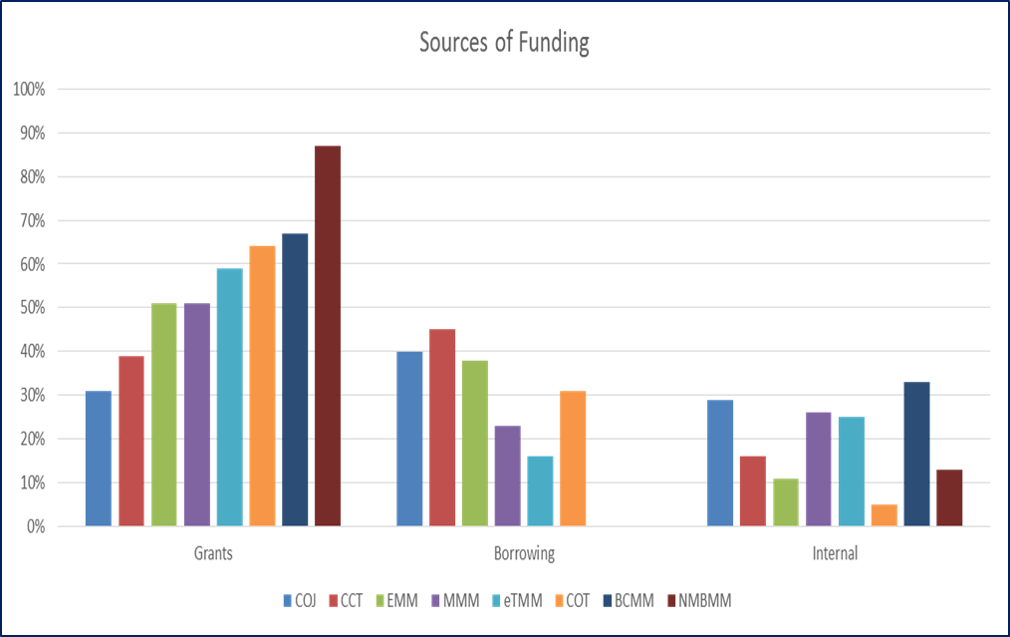

SA Metros’ borrowing exposure as at June 2014 was as follows:

|  |  |
| --- | --- |
| **Metro** | **Debt (borrowings exposure)**  **Norm: 40-45%** |
| Buffalo City | 14% |
| Cape Town | 26% |
| Johannesburg | 38% |
| Ekurhuleni | 27% |
| eThekwini | 46% |
| Mangaung | 13% |
| Nelson Mandela Bay | 27% |
| Tshwane | 45% |

*\*Source: National Treasury*

According to the table above, 25% of the cities have been “over-exposed” in terms on borrowings, or have reached the 40-45% norm on borrowing. 75% of the metros still have an opportunity to borrow and invest on urban infrastructure through different instruments. It is evident from the above data that City of Tshwane and eThekwini may have reached their borrowings norm (above 40-45%). This may not necessarily mean that the two cities cannot embark on any borrowing process, but it may be that there is a lack of a long term financing strategy that may unlock other funding alternatives in the future. However, National Treasury has emphasised that what metros borrow for, should be for revenue generating infrastructure that will further enhance their financial standing.

In the 2015/16 BEPPs, there was very little indication of project financing for the pipeline of catalytic projects. Most of the BEPPs listed the projects but failed to indicate the funding model for same. Furthermore, there were inconsistencies between the funding provided in the BEPP and funding information provided in other planning and budgeting instruments such as the MTREF budget.

### Objectives

The aim of this evaluation is to evaluate/assess the draft 2016/17 Metro BEPPs. The main objectives of the evaluation are:

* To identify what financial information is missing from the BEPPs (information that would attract funders and private investors to invest in the BEPP Project pipeline);
* To make recommendations of what key information should be reflected in the 2017/18 BEPPs to improve the financial closure of the BEPP (to be financeable and bankable);
* To make inputs towards the improvement of the 2017/18 BEPP guidelines (financial component); and
* To rate the quality of the BEPPs per metro on a scale of 1-4

This is summarised as follows:



### Scope

The scope of the evaluation is limited to the Capital Funding components of the BEPP, and relates directly to the Built Environment Value Chain (BEVC) depicted below:

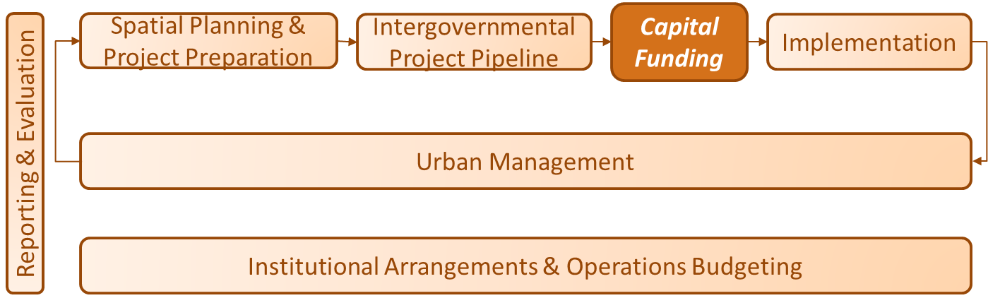

The importance of addressing the capital financial and funding requirements within the BEVC is crucial without which metros will be able unable to implement their BEPPs as summarised below:

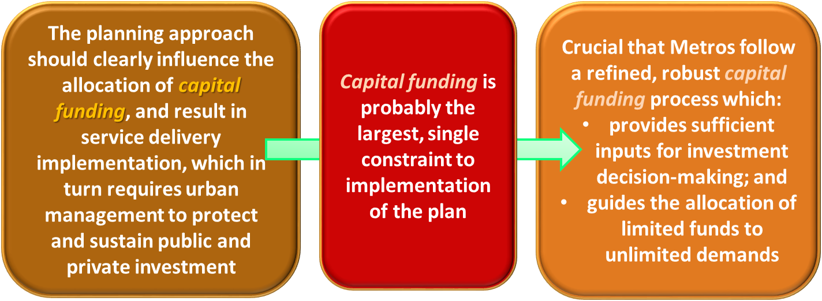

In the 2016/17 BEPP guidelines, reference has been made that the DBSA would conduct an annual technical desk-top evaluation of the Built Environment Performance Plans (BEPP) to assess how effectively BEPPs are financed at an institutional and project/programme pipeline level.

The criteria applied to conduct this evaluation is as follows:

* City’s borrowing capacity and high level financial health;
* Availability of a long term financing strategy for spatial transformation;
* Project/programme pipeline detailed information (including status of projects);
* Estimated project costs/value;
* Confirmed funding sources over the MTEF cycle;
* Alternative funding sources, if any;
* Projected potential revenue; and
* Inter-governmental and sector plan alignment

### Progressive model

The current evaluation is a progression from that conducted in the previous cycles; and focuses specifically on the capital funding component of BEPPs as depicted in the figure below:

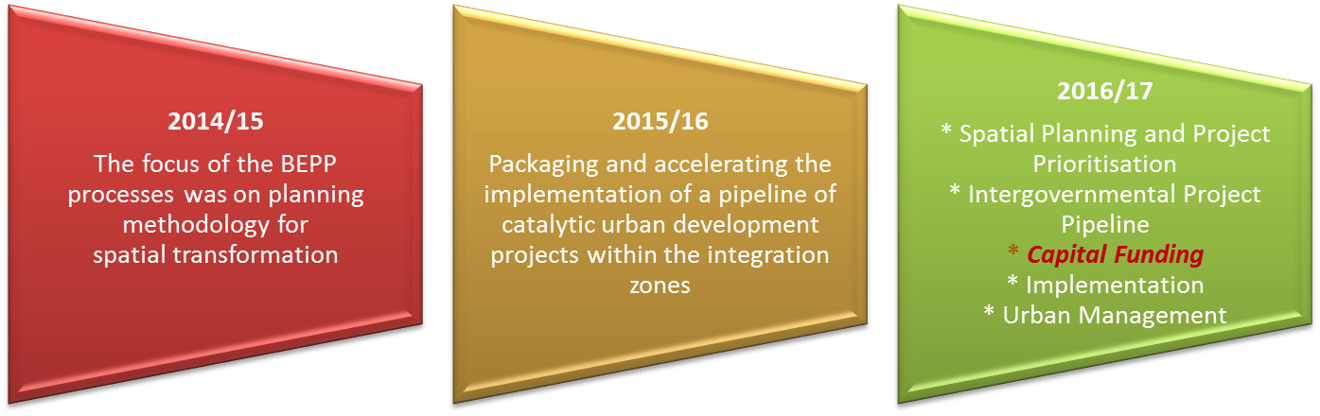

The 2016/17 Medium Term Revenue and Expenditure Framework (MTREF) is the 3rd annual cycle of the built environment performance plans (BEPPs) and associated processes. The focus of the 2014/15 BEPP processes was on planning methodology for spatial transformation and in 201516 the focus shifted to packaging and accelerating the implementation of a pipeline of catalytic urban development projects within the integration zones.

The work on defining the built environment outcomes and impacts, and the resultant indicators to measure spatial transformation started in 2013. In addition, cities have spent time between 2013 and 2014 working out what support they required from the Cities Support Programme to assist them to achieve their spatial targeting goals and objectives, and this is reflected in their City Support Implementation Plan (CSIP).

The identification and planning of Urban Networks and Integration Zones was the key focus of the 2014/15 BEPP. Subsequently the 2015/16 BEPP guidelines encouraged the refinement and consolidation of the planning of urban networks and Integration Zones done the year before, and went a step further by requiring the identification, packaging and implementation of a pipeline of catalytic urban development projects within the Integration Zones. In addition, there was a specific focus on the upgrading and development of informal settlements and other marginalised areas.

The key findings related to the capital funding aspects of the previous BEPPs are reflected below:

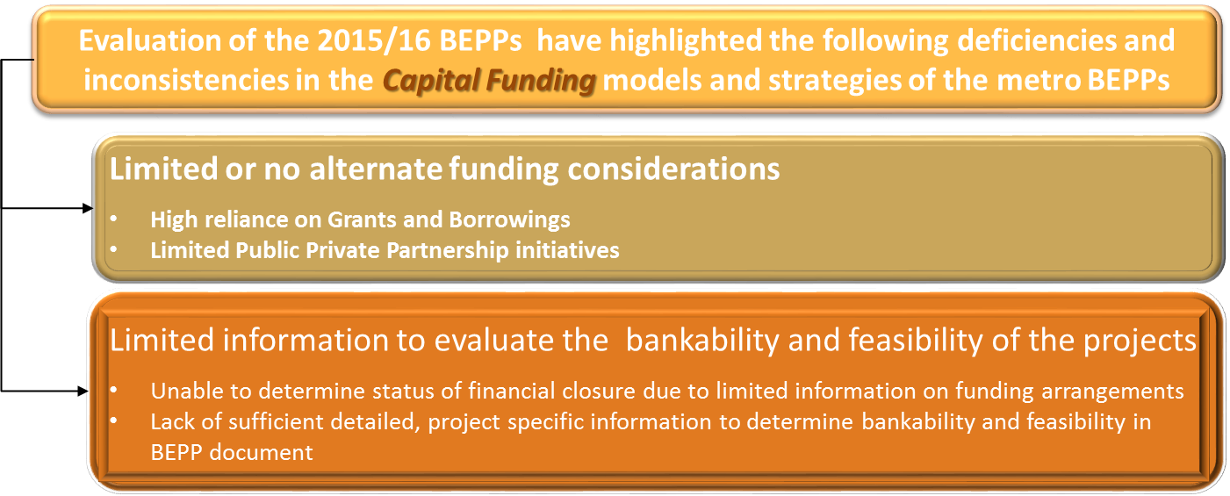

These findings emphasise the need for metros to focus on the capital funding requirements to facilitate the achievement of the goals and objectives detailed in their respective BEPPs.

### Approach

The approach consisted of a desktop review of the following documents for each of the eight metros, relating to the 2016/17 – 2018/19 MTREF period:

* BEPP guidelines;
* BEPP;
* SDBIP (limited to Schedule SA8)
* Budgets; and
* Credit rating analysis (where available)

Each of the current BEPPs were assessed to determine the adequacy of the Capital Funding and financial information contained therein. The objective was to evaluate whether the BEPPs contained sufficient information to attract funders and private investors to invest in the BEPP Project pipeline.

Desktop reviews were also performed to obtain insights into international best practice related to public sector infrastructure development and in particular funding thereof. The criteria utilised by Development Financing Institutes (DFIs) to assess the bankability of infrastructure projects, was used as the reference to evaluate the finance-ability of the metros’ catalytic projects.

Following which recommendations were developed on the key information that should be reflected in the 2017/18 BEPPs to improve financial closure and to be financeable and bankable. The final stage in the evaluation was to perform a high-level ratting of each of the BEPPs.

The outcomes of the evaluation together with recommendations to improve the quality of the BEPPs are detailed in the sections that follow.

### Framework: Bankability and Finance-ability Criteria and Guidelines

In order to raise the necessary funds that are necessary to implement the Catalytic projects, it is important that metros consider the “bankability” of the catalytic projects that are identified in the BEPP. Bankability simply means *lenders are comfortable to lend money* to the project because it is:

* Underpinned by *sound, financial and market information*, which means it’s able to *generate enough cash flows to service the financing and still be profitable*; and
* Underpinned by *sound technical and institutional arrangements* which gives it *longevity and sustainability*.

### Comprehensive Plans and Models

It is however important to note that in order for National Treasury as well as potential investors to perform a bankability assessment, evidence of the following is required:

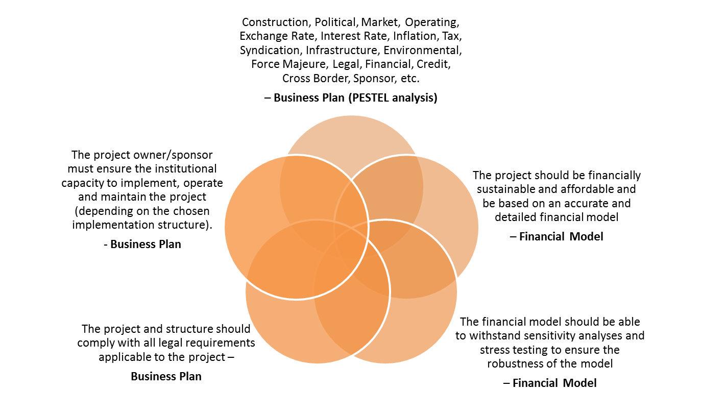

* A business plan

The project must be appropriately formulated, designed and structured for the infrastructure to be provided (e.g. as a PPP, Corporate Finance, Project Finance or a blend of these structures);

* Pre-feasibility Studies/Concept Plans

Technical studies and investigations should have been done to a sufficient level of detail to ensure accurate cost estimates and to address the project risks discussed above

* Financial models

The financial models must provide evidence that the project is financially sustainable and affordable based on accurate and detailed financial information. The model must be able to withstand sensitivity analyses and stress testing to ensure the robustness of the model.

### DFI Project Funding Criteria

Development Finance Institutions (DFI) typically focus on public and private sector projects that enhance regional integration; similar in nature to the catalytic projects that are contained in the BEPP. The criteria used by the DFI to assess the bankability of a project is illustrated below:

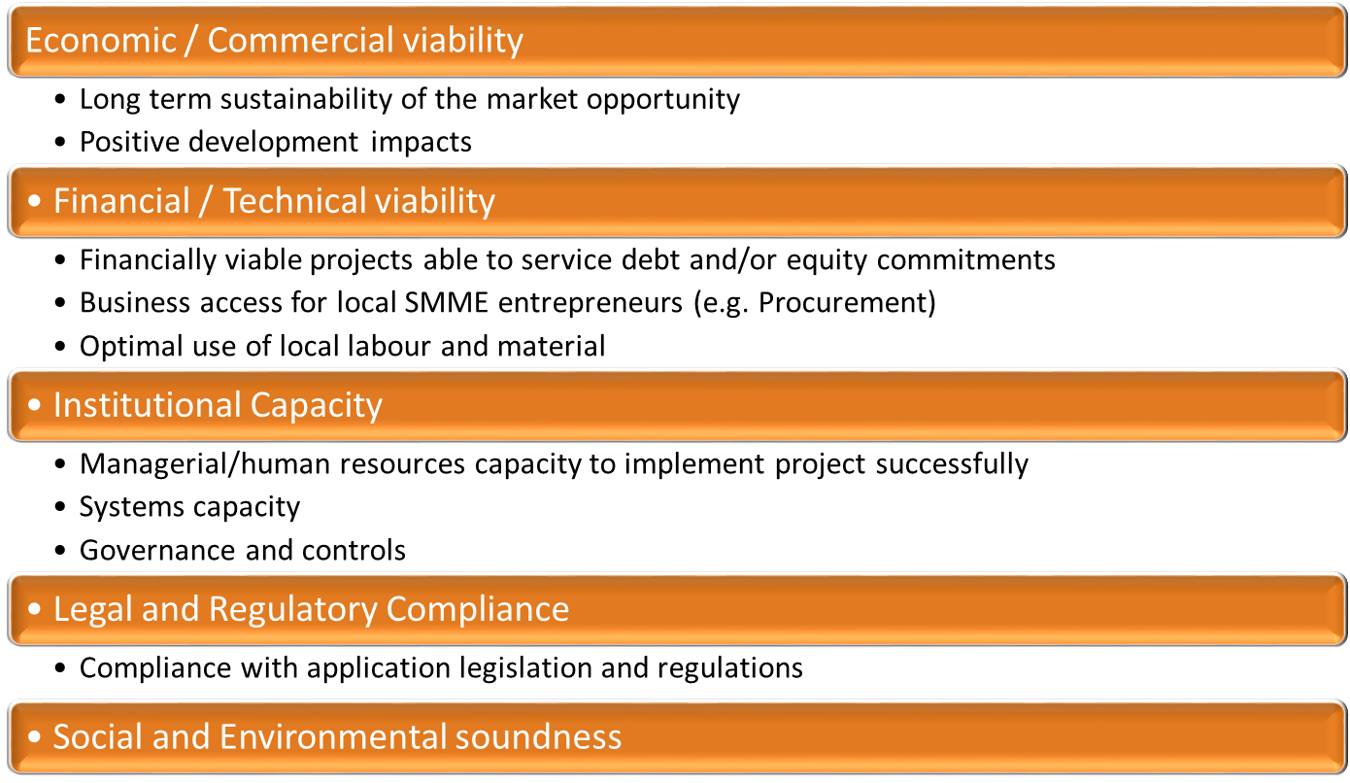

When preparing business plans and financial models to support infrastructure development concepts, it is useful for metros to consider the project funding criteria used by DFI. In addition, metros should address the following key concerns for financiers in their final project feasibility studies:

* Lack of equity
  + Metros should consider options to attract 3rd party sources of equity, if sponsor equity is limited;
* Weak sponsors (limited financial, technical and management expertise)
  + Metros should supplement their staff with contracted 3rd party expertise e.g. Management/Technical Partner;
* Inadequate off-take agreement
  + Metros should seek guarantees from stronger party e.g. blue-chip companies;
* Inadequate security package on offer;
* Foreign exchange and convertibility risk; and
* Lack of capacity of sponsors to structure and package projects

### National Treasury 2016/17 BEPP Guidelines

The purpose of the BEPP guidelines is to provide metros with guidance in the preparation of their BEPPs 2016/17– 2018/19 in terms of the annual Division of Revenue Act (DORA). The guidelines note that the budgeting process is regulated by the MFMA and has shown vast improvement over the last few years in terms of being medium term budgets that are funded, credible, relevant and reliable. Yet there is a need to go beyond legislative and regulatory compliance and have a  
long term financing strategy and plan at an institutional level which provides a framework for  
project-level financing of the metropolitan pipeline of catalytic urban development projects.  
The IDP, Budget and the BEPP of most cities currently do not focus on a long term financing  
strategy.

In terms of requirements and expectations, the guidelines propose that the BEPPs should clearly articulate the long term financing need and strategy for spatial transformation. This financing strategy should be based on the plan for spatial transformation – the spatial targeting approach that results in the identification of urban networks, Integration Zones, areas where service backlogs need to be addressed, informal settlements, marginalised areas, and growth nodes for economic development. The long term financial strategy provides the framework for investment activities that relate specifically to the financing of projects within Integration Zones.

In respect of content and format requirements, the guidelines indicate the following for Section D of the BEPP report:

* Section D1 Spatial budget mix

High level allocation of capital budget to each of the following 3 spatial targeting categories in terms of total capital budget from all funding sources:

* + Urban Network identification and prioritisation of Integration Zones;
  + Marginalised areas (Informal settlements, Townships and Inner City Areas) identification and prioritization; and
  + Growth nodes (commercial and industrial) identification and prioritisation
* Section D2 Investment strategy

This section should describe the investment strategy for the intergovernmental project pipeline

* Section D3 Institutional arrangements and operating budget

The guidelines recommend that the following aspects be disclosed:

* + Leadership, good governance and planning (strategic and operational);
  + Inter-sectoral municipal & consultation with PG, SOE’s and National Departments responsible for asset creation for service delivery directly to the public (e.g. SAPS);
  + Risk mitigation strategies;
  + Operating budget implications; and
  + City Support Implementation Plan

These requirements are illustrated in the diagram below:

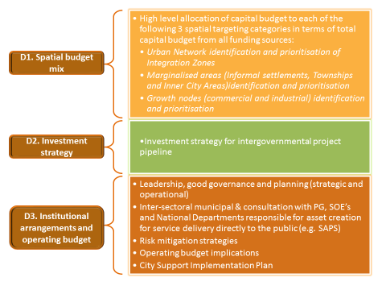

### Evaluation and Recommendations

This section consolidates the objectives, generally accepted best practice, observations and recommendations arising from the evaluation of the eight metros. The following key aspects are discussed in further detail:

* Consolidated metropolitan capital funding requirements, including an analysis of the funding mix;
* The financial status and borrowing capacity of each metropolitan, with focus on the following areas:
  + Credit ratings;
  + Financial ratios;
  + Cash-generating project pipeline;
  + Long-term financial strategy; and
  + Off-balance sheet initiatives;
* Project pipeline and funding; and
* Risk identification and mitigation

### Consolidated Metro Capital Funding Requirements

As illustrated below, metros remain significantly dependent on grant funding to finance catalytic infrastructure projects.

|  |  |  |  |  |
| --- | --- | --- | --- | --- |
| **Metro** | **Grants** | **External loans** | **Own Revenue** | **Capital Budget** |
| **Buffalo City** | 925 | - | 425 | 1,350 |
| **Nelson Mandela Bay** | 1,032 | - | 565 | 1,597 |
| **Mangaung** | 793 | 1,072 | 527 | 2,392 |
| **Ekurhuleni** | 2,200 | 1,812 | 945 | 4,957 |
| **City of Johannesburg** | 2,891 | 2,506 | 4,454 | 9,851 |
| **City of Tshwane** | 2,507 | 1,200 | 285 | 3,992 |
| **eThekwini** | 3,682 | 1,000 | 1,753 | 6,435 |
| **City of Cape Town** | 2,382 | 1,500 | 845 | 4,727 |
| **Total** | **16,412** | **9,090** | **9,799** | **35,301** |

|  |  |  |  |  |
| --- | --- | --- | --- | --- |
| **Consolidated Capital Funding Mix** | | | | |
|  | **Grants** | **External loans** | **Own Revenue** | **Capital Budget** |
| **%** | **46** | **26** | **28** | **100** |
| **Total** | **16,412** | **9,090** | **9,799** | **35,301** |

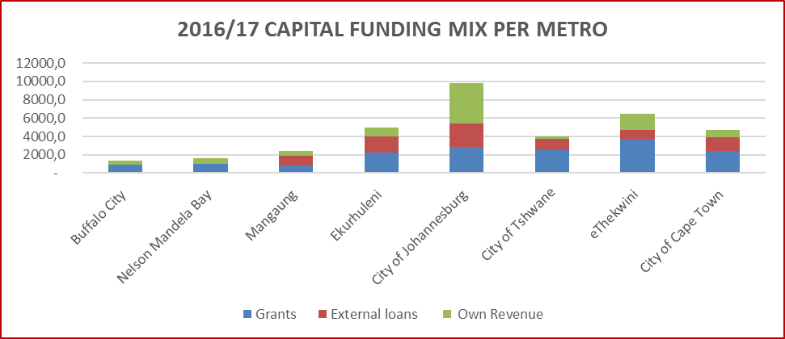

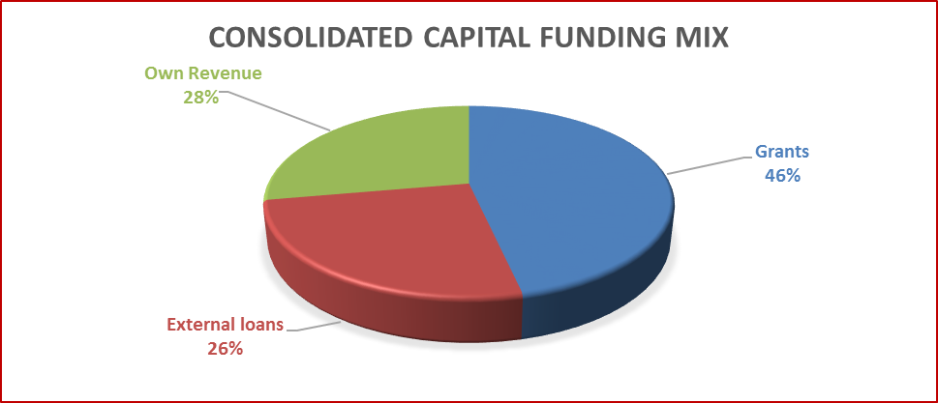

Metros utilise three sources of funding:

* Grant funding;
* Borrowings; and
* Internal funding (including own revenues and public contributions)

As is evident from the graph above, 46% of the combined total capital projects are financed through grant funding; whilst borrowings account for 26%, with internal funding making up 28% of total funding requirements (noting that CoJ portion is 45% of the total internal funding component). The individual funding mix for each metro is detailed in the table which follows:

|  |  |  |  |
| --- | --- | --- | --- |
| **Metro** | **Grants** | **Borrowing** | **Internal** |
| Mangaung | 33% | 45% | 22% |
| Ekurhuleni | 44% | 37% | 19% |
| City of Cape Town | 50% | 32% | 18% |
| City of Tshwane | 63% | 30% | 7% |
| City of Johannesburg | 29% | 25% | 45% |
| eThekwini | 57% | 16% | 27% |
| Buffalo City | 69% | 0% | 31% |
| Nelson Mandela Bay | 65% | 0% | 35% |

The significant dependence on grant funding ranging between 29% (City of Johannesburg) and 69% (Buffalo City) of individual metro capital budgets, remains a cause for concern, without which metros will be severely compromised in delivering against their mandates. Whilst borrowings for most metros are within an acceptable range, the cost of borrowings as well as the questionable bankability of catalytic projects are both deterrents in this respect. Clearly metros have to implement interventions to become financially independent through which they would be able to finance a greater portion of the infrastructure portions. They also have to become more innovative in identifying funding mechanisms to partner with the private sector on these projects without which these goals will be unsustainable and metros will fail to achieve their longer-term catalytic goals.

### Planned External Loans

A closer evaluation of the budgeted external loans (borrowings) component of the capital budget reveals that metros plan to borrow a total of R9bn in the 2016/17 financial year as detailed below:

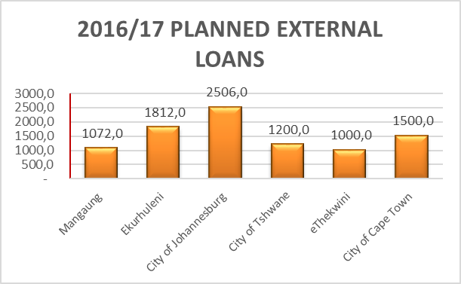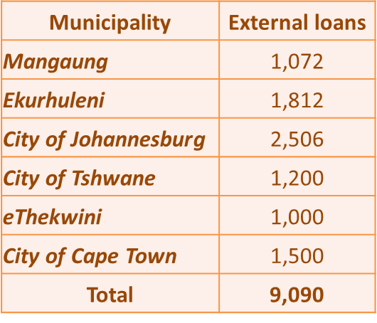

Since this forms almost 26% of the total Capital Funding requirements, the implementation of catalytic projects, will be severely constrained should metros be unable to raise these loans.

RECOMMENDATIONS – CAPITAL FUNDING

* It is therefore crucial that Metros follow a refined, robust Capital Funding process which:
* provides sufficient inputs for investment decision-making; and
* guides the allocation of limited funds to unlimited demands

BEPPs must therefore contain sufficient information in respect of the degree of financial closure in respect of these external loan applications

### Financial Status and Borrowing Capacity of Metropolitans

### Credit Ratings

**The Preamble which follows is an extract from the 2015/16 BEPP Evaluation Report and is included here for ease of reference.**

**This is followed by details related to the 2016/17 evaluation.**

Moody's Investors Service, often referred to as Moody's, is the bond credit rating business of Moody's Corporation, representing the company's traditional line of business and its historical name. Moody's Investors Service provides international financial research on bonds issued by commercial and government entities and, with Standard & Poor's and Fitch Group, is considered one of the Big Three credit rating agencies.

The company ranks the creditworthiness of borrowers using a standardised ratings scale which measures expected investor loss in the event of default. Moody's Investors Service rates debt securities in several market segments related to public and commercial securities in the bond market. These include government, municipal and corporate bonds; managed investments such as money market funds, fixed-income funds and hedge funds; financial institutions including banks and non-bank finance companies; and asset classes in structured finance. In Moody's Investors Service's ratings system securities are assigned a rating from Aaa to C, with Aaa being the highest quality and C the lowest quality.

Moody’s has recently downgraded South Africa’s debt rating to Baa2 from Baa1. The key drivers of the rating downgrade are the following:

* Poor medium-term growth prospects due to structural weaknesses, including ongoing energy shortages as well as rising interest rates, further deterioration in the investor climate and a less supportive capital market environment for countries such as South Africa that are highly dependent on external capital.
* The prospect of further rises in the government debt-to-GDP ratio implied by the low-growth environment, which even strict compliance with the government spending ceiling and somewhat smaller fiscal deficits are unlikely to arrest in the near term.

The assignment of a stable outlook reflects policymakers' commitment to reining in government debt growth over the medium term and the broad political support for a macroeconomic strategy, including the National Development Plan (NDP), tighter monetary policy and fiscal restraint, which should help stabilize the debt burden over the medium term.

The following key points should be noted from Moody’s recent evaluation of South African metros:

* Moody’s has downgraded all metropolitan cities’ long-term ratings by one notch, with the exception of Nelson Mandela Bay to reflect the deterioration of South Africa’s credit profile;
* The centralised nature of the local public sector results in close operational and financial linkages between the national government and municipalities;
* Large cities are exposed to the country’s macroeconomic performance and socio-economic conditions to varying degrees;
* While metropolitan cities rated by Moody’s display comparatively rich economic bases, sound financials and good governance practices, they remain dependent on decisions of the central government, which maintains a high degree of control over the sector via legislation;
* Furthermore, the cities’ budgetary structures and relative sizes heavily exposes them to the country’s macroeconomic performance and socio-economic conditions;
* In addition, they feature moderate-to-high debt levels, which adds rigidity to their budgets and
* Moody’s expects that weaker-than-anticipated economic growth prospects in the medium term will put pressure on the cities’ overall financial performances.

As metros compile their BEPPs, they should specifically note that the successful implementation of planned structural reforms to enhance potential growth and reduce exposure to external shocks, combined with continued fiscal prudence, and could exert upward pressure on the rating. Reforms resulting in higher domestic savings and investment rates and sustainable, stronger growth, alongside continued restraint in public debt accumulation and the ongoing implementation of the macro- and micro-level reforms embedded in the NDP, could also provide positive momentum to the rating. Thus metros play a crucial role, through their BEPPs, in the attractiveness of external investors to South Africa.

### Evaluation of 2016/17 Credit Rating

As discussed above, the purpose of the credit rating is to provide investors with a simple system of gradation by which future relative creditworthiness of securities may be gauged. The evaluation of the credit ratings extracted from Schedule SA8, 2016/17 MTREF of each metro is summarised below.

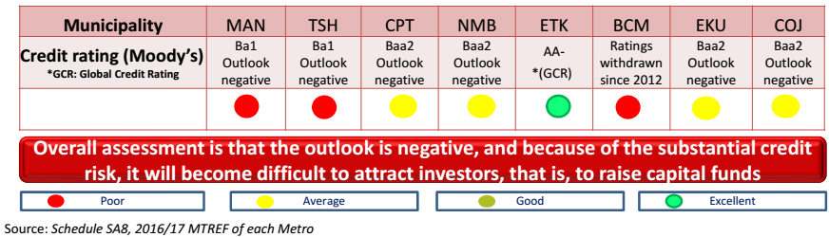

Due to Moody’s ratings being largely average tending towards negative, potential investors will consider investments in metro projects as high-risk. This will result in metros being under increased pressure to raise loans, which will have an adverse impact on their ability to implement the project pipeline.

RECOMMENDATIONS – CREDIT RATINGS:

* The name of the agency responsible for the credit rating must be disclosed in relevant documentation to facilitate verification of the rating.
* The discrepancy between the credit ratings disclosed in SA8 and Moody’s must be resolved. This discrepancy generates uncertainty in the minds of potential investors.
* Schedule SA8, which includes the credit ratings, should be incorporated into the BEPP for ease of reference.
* Long-term financial strategies must be developed with the objective of improving current credit ratings which will make investment in catalytic capital infrastructure programmes and projects attractive to investors.

### Financial Ratios

Financial statement analysis the process of analysing financial statements of a borrower so as to obtain meaningful information about its survival, stability, profitability, solvency and growth prospect. The financial statement analysis can be performed by using a number of techniques with financial ratio analysis being the most popularly and widely used technique of financial statement analysis.

Financial ratio analysis is an important tool for analysing an entity’s financial performance. The following are the important advantages of the accounting ratios.

* Analysing Financial Statements

Ratio analysis is an important technique of financial statement analysis. Accounting ratios are useful for understanding the financial position of the entity. Different users such as investors, management. bankers and creditors use the ratio to analyse the financial situation of the entity for their decision making purpose.

* Judging Efficiency

Accounting ratios are important for judging the metro’s efficiency in terms of its operations and management. They help judge how well the metros has been able to utilise its assets and earn profits.

* Locating Weakness

Accounting ratios can also be used in locating weakness of the organisation’s operations even though its overall performance may be quite good. Management can then pay attention to the weakness and take remedial measures to overcome them.

* Formulating Plans

Although accounting ratios are used to analyse the metro’s past financial performance, they can also be used to establish future trends of its financial performance. As a result, they help formulate the metro’s future plans.

* Comparing Performance

It is essential for an organisation to know how well it is performing over the years and as compared to the other firms of the similar nature. Besides, it is also important to know how well its different departments are performing among themselves in different years. Ratio analysis facilitates such comparison.

In performing financial analysis potential borrowers and investors use these ratios an index or yardstick for evaluate the financial position and performance of the potential borrower. Metros should therefore review their financial ratios to enable them to make quantitative judgement (much as the potential investor) about the financial position and performance of the firm. It will provide valuable insights into their strategies to sustain and improve performance.

### Evaluation of 2016/17 Financial Ratios

The purpose of financial ratio analysis to provide investors to assess the relative strength of investments by performing simple calculations on items on income statements, balance sheets and cash flow statements. The evaluation of the key financial ratios extracted from Schedule SA8, 2016/17 MTREF of each metro is summarised below.

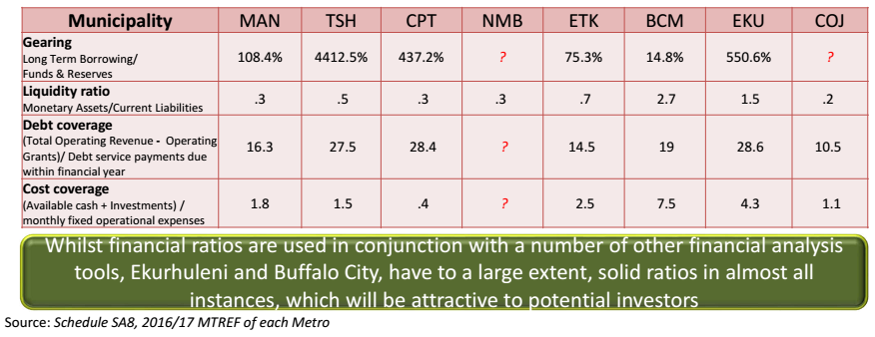

The following table describes the use of the selected financial ratios.

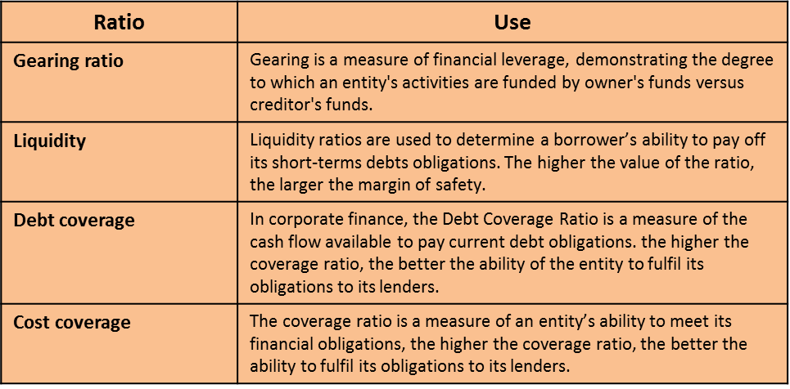

In general, the financial ratios are positive and would exert a favourable influence on potential investors. However, investors for purposes of decision-making rely on a number of financial ratios, amongst other tools, thus the favourable ratios will not in themselves result in a positive outcome to requests for funds.

RECOMMENDATIONS – FINANCIAL RATIOS:

* The relevance, use and accuracy of the ratios reflected in schedule SA8 should be reviewed and revised as necessary.
* The revised Schedule SA8, including relevant financial ratios, should be incorporated into the BEPP for ease of reference.
* Metros must investigate the gearing ratio calculation, which reflects the amount of existing equity that would be required to pay off all outstanding debts. [*Metro documents reflect very high gearing ratios, and entities with ratios upward of 50% for example, represent a greater risk, because even a brief period of a sudden increase in interest rates could mean significant cash flow constraints and potential loan default].*
* The cause of suboptimal financial ratios must be investigated in detail and short and long-term financial strategies must be developed with the objective of improving financial efficiency and effectiveness which will promote investor confidence in investing in catalytic capital infrastructure programmes and projects attractive to investors.

### Cash-generating Project Pipeline

Cash flow analysis is a critical process for both the metros and investors. One of the most important features that is examined in a potential investment is the metro’s ability to produce cash. Even though a metro may appear profitable on the income statement does not imply that it will not face challenges later because of insufficient cash flows. A close examination of the cash flow statement can give investors a better sense of how the metro will fare.

Organisations produce and consume cash in different ways, so the cash flow statement is divided into three sections: cash flows from operations, financing and investing. Basically, the sections on operations and financing show how the company gets its cash, while the investing section shows how the company spends its cash.

* Cash Flows from Operating Activities

This section shows how much cash comes from revenues derived from the provision of services, less the amount of cash needed to provide those goods and services. Investors tend to prefer entities that produce a net positive cash flow from operating activities. Public sector entities tend to show negative cash flow from operations especially where there is limited focus on generating their own revenues. At the same time, changes in cash flow from operations typically offer a preview of changes in net future income. Normally it is a positive indicator when it goes up. Investors are particularly cautious where there is a widening gap between the metro’s reported earnings and its cash flow from operating activities.

* Cash Flow from Financing Activities

This section describes the movements of cash associated with outside financing activities. Typical sources of cash inflow would be cash raised by selling bonds or by bank borrowings. Likewise, payment of bank loans would be reflected as use of cash flow.

* Cash Flows from Investing Activities

This section largely reflects the amount of cash the metro has spent on capital expenditures. It also includes monetary investments such as money market funds. Investors want to see a metro company re-invest capital in its business by at least the rate of depreciation expenses each year. If it does not re-invest, it might show artificially high cash inflows in the current year which may not be sustainable.

The philosophy behind investment in cash-generating projects is illustrated below:

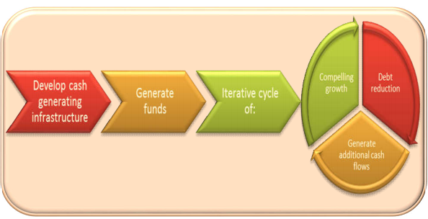

Savvy investors are attracted to organisations that produce plenty of free cash flow (FCF). Free cash flow signals the metro’s ability to repay debt and facilitate the growth and sustainability of operations. Free cash flow, which is essentially the excess cash produced by the metro, can be invested in new growth opportunities without constraining the existing operations.

Ideally, investors would like to see that the metro can pay for the investing figure out of operations without having to rely on outside financing to do so. A metro’s ability to pay for its own operations and growth signals to investors that it has very strong fundamentals.

### Evaluation of 2016/17 Cash-generating Pipeline

The objective of evaluating the cash-generating project pipeline enables investors to determine whether planned projects will generate sufficient cash to repay itself and support further growth of the metro.

The findings from this aspect of the evaluation of the BEPP of each metro is summarised below.

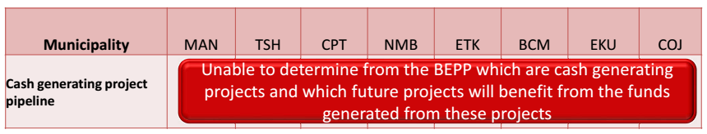

Based on the desk-top review of the BEPPs, it was not possible to determine whether planned projects were cash-generating.

RECOMMENDATIONS – CASH GENERATING PROJECTS:

* Metros should identify and prioritise investment in cash generating projects
* Metros should incorporate the estimates of funds to be generated from these investments into their financial strategies, cash flow projections and planning the rollout of subsequent projects
* Cash generating projects, should be clearly identified, and disclosed in the BEPP detailing projected cash flows and planned use of these funds

### Long-term Financial Strategy

Strategic planning is many things, but it surely includes the processes of deciding how to commit the metros’ resources across its different departments. The financial side of strategic planning allocates a particular resource, finance.

Strategic financial management is managing the metros financial resources so as to achieve its operational objectives and maximise its value. Strategic financial management involves a defined sequence of steps that encompasses the full range of the metro’s finances, from setting out objectives and identifying resources, analysing data and making financial decisions, to tracking the variance between actual and budgeted results and identifying the reasons for this variance. The term "strategic" means that this approach to financial management has a long-term horizon.

A finance strategy is integral to the metro’s strategic plan. It sets out how the metro plans to finance its overall operations to meet its objectives in the short- and long-term. The financial strategy summarises targets, and the actions to be taken over the immediate and future periods to achieve the targets. It also clearly states key policies which will guide those actions. The strategy is informed by the risks and opportunities that have been identified. It must include as a minimum:

* The desired funding mix – the balance and sources of restricted and unrestricted funds;
* Grant dependency – expressed as a percentage of overall income;
* Level of general reserves – usually expressed as the number of days that the metro could continue without external funding;
* Funding needs – with particular focus on development of catalytic infrastructure programmes
* Actions and interventions to be undertaken by the metro each year to finance the strategic plan and achieve the financial targets identified. This should include sections on:
* Strategy to increase the mix and level of unrestricted funds;
* Strategy to finance core costs;
* Strategy to build up reserves;
* Strategy to replace and maintain fixed assets; and
* Strategy to apply funds to achieve maximum benefit
* Example of actions to increase the percentage of unrestricted income might include:
* increasing or introducing fees for users of services to recover some or all of the costs of providing the service;
* introducing income-generating activities;
* making use of under-utilised resources (e.g. renting out office space, vehicles); and
* increasing the priority given to generating internal revenues.
* Policies that guide the financing strategy which can include:
* Reserves policy – what level of reserves are to be accumulated, and how surpluses will be handled.
* Core costs policy – what method will be used to recover programme support costs from projects and funders. It will also clarify the policy on subsidising ‘poorer’ projects and how that will be decided and managed.
* Pricing and cost recovery policy – where charges are to be made to service users, this will explain the basis and formula used for the charging, and the pricing structure.

The key steps of the development of the Finance Strategy is illustrated below:

The long-term finance strategy provides investors with the confidence that the metro has developed the necessary plans to remain on track to attain its short-term and long-term goals, while maximizing value for its citizens and stakeholders.

### Evaluation of 2016/17 Long-term Financial Strategy

The purpose of the evaluation is to determine whether the metro has a long-term financial strategy. This provides insight into the future financial capacity to achieve long-term sustainability in light of the metro’s service objectives, financial challenges and the overall catalytic infrastructure demands.

The findings are summarised below:

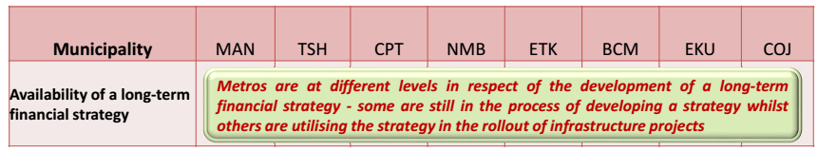

It is recognised that metros are at different levels of maturity in this respect. Since metros realise the importance of a long-term financial strategy, all metros are actively engaged in different stages of the long-term financial development and implementation process.

RECOMMENDATIONS – LONG TERM FINANCIAL STRATEGY:

* All metros should develop long-term financial strategies as a matter of urgency, and take into consideration the following:

1. Time Frame - at least five to ten years into the future.
2. Scope - should consider all appropriated funds, but especially funding related to capital expenditure for catalytic infrastructure projects
3. Frequency - should be updated as needed in order to provide direction to the budget process
4. Content - should include:
   1. an analysis of the financial environment;
   2. revenue & expenditure forecasts;
   3. debt position & affordability analysis;
   4. strategies for achieving & maintaining financial balance; and
   5. plan monitoring mechanisms, such as scorecard of key indicators of financial health
5. Visibility - should devise an effective means for communicating this information, through either separate plan documents or by integrating it with existing communication devices.

* Relevant sections of the long-term financial strategy should be included in the BEPP, especially where this is of significance to a potential investor

### Off-Balance Sheet Initiatives

Off-balance sheet (OBS) items refer to assets or liabilities that do not appear on the metro’s balance sheet but that are nonetheless effectively assets or liabilities of the metro. Assets or liabilities designated off-balance sheet are typically ones that the metro is not the recognised legal owner of, or in the case of a liability, does not have direct legal responsibility for. As an example, an operating lease is one of the most common off-balance items. Other examples are illustrated below:

Off-balance sheet items are an important concern for investors in regard to assessing a metro’s financial health. Off balance sheet items are often difficult to identify and track within the metro’s financial statements because they might only appear in the accompanying notes. Another concern is that some off-balance sheet items have the potential to become hidden liabilities. Off- balance sheet items are not inherently intended to be deceptive or misleading to investors. Off-balance sheet items are also used to share both risks and benefits of assets and liabilities with other companies, as in the case of joint venture projects.

Through off-balance-sheet financing large capital expenditures may not be reflected on a metro’s balance sheet. Investors are aware that organisations often use off-balance-sheet financing to keep their debt to equity (D/E) and leverage ratios low, especially if the inclusion of a large expenditure would result in negative financial ratios. Particular attention should therefore be given to ensuring that such items are fully disclosed to potential investors.

### Evaluation of 2016/17 Off-Balance Sheet Arrangements

The rationale supporting the evaluation of off-balance sheet items is that this is of particular interest to investors trying to determine the financial health of the metro, noting that these items are harder to track, and can become hidden liabilities.

The evaluation of the off-balance sheet items of each metro is summarised below.

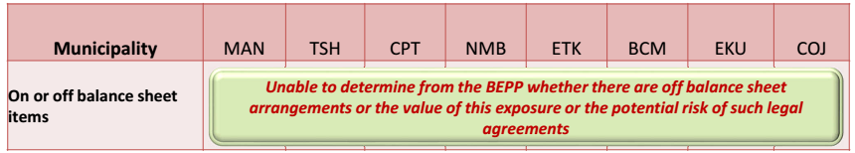

It was not possible to determine from the BEPPs whether metros have off-balance sheet funding or the significance of such arrangements.

RECOMMENDATIONS – OFF-BALANCE SHEET ARRANGEMENTS:

* Metros should disclose off-balance sheet arrangements under the following conditions:
  + the risks or benefits arising from arrangements are material;
  + only to the extent necessary for enabling the financial position of the company to be assessed, particularly by potential investors
* Metros should factor the potential impact of these arrangements into the calculations of their financial ratios, where appropriate
* Material off-balance sheet items should be disclosed in the BEPP, with an indication of the benefits and risks, if applicable, of such arrangements

### Project Pipeline Funding

**The Preamble which follows is an extract from the 2015/16 BEPP Evaluation Report and is included here for ease of reference**

### Development of a Comprehensive Funding Plan

Once a municipality has identified its capital projects and developed a reasonably clear and affordable capital investment plan, it should be tested against the potential funding sources and funding structures, to determine the most appropriate funding strategy. The capital investment plan should not be finalised until its funding implications have been tested and found acceptable.

For example, the relationship between the structure of the debt and the timing of capital projects is an important matter. The municipality must have funds available when required but should receive a loan, on which interest is paid, which then sits idle in the municipal bank account. The funding plan should be that the capital programme is never without funds, but without incurring any such `negative arbitrage’.

It is recommended that the metros follow the process below to develop their funding plan, which should therefore fit into the planning and budgeting cycle and should not be seen as an afterthought.

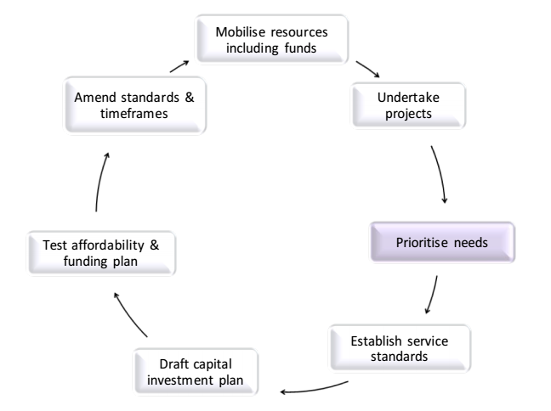

The comprehensive funding plan should address all of the following components:

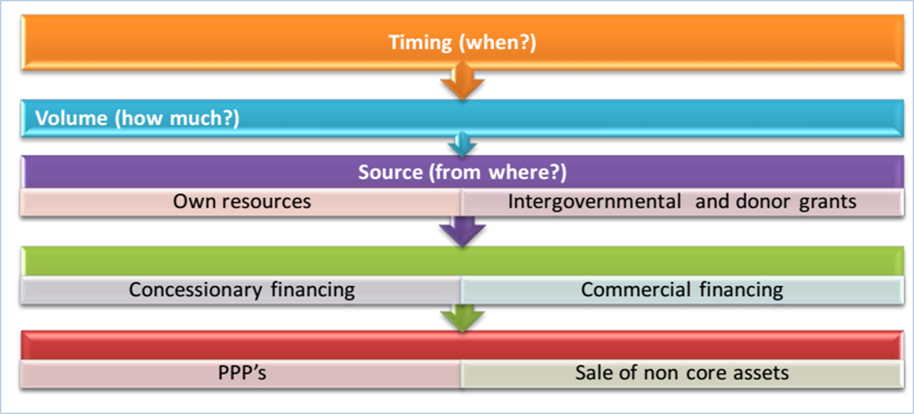

The sources of funding are discussed in further detail in the following section.

### Innovative Solutions to Funding Requirements

### Private Sector Partnerships

The Private Sector has an important role to play in managing service delivery, investing in service delivery companies and in financing infrastructure investments. The possibilities offered through innovative arrangements which could bring the private sector into these functions, should be explored.

The metros should be firmly committed to a partnership approach to development. Public-private sector partnerships represent in important union for more effective service delivery. These partnerships may take many forms and should not be confined to the private sector simply being represented on fora, committees and commissions or tendering for certain contracts. In terms of service delivery, a range of creative partnerships can be established to the mutual benefit of both parties and the consumer. Partnerships can be formed to manage and administer certain services on behalf of the Local Authority, to invest in service delivery companies (often jointly with overseas investors) or to finance infrastructure investments. Such arrangements could vary between corporatisation of local government departments into independent, business units, service contracts, lease arrangements, "build-operate-transfer (BOT)", "build-operate-own (BOO)" arrangements through to full-scale privatisation. Not all these options will be viable everywhere - at least not in the short-term and possibly not even in the long-term. Care must therefore be taken to ensure that the choice of delivery mechanisms does not effectively curb the ability to deliver. The choice of a particular option requires careful consideration by a local authority as a number of factors and influences need to be weighed up.

In exploring public/private delivery options, metros should apply the following criteria:

* Efficiency;
* Equity;
* Cost-effectiveness;
* Leverage of private investment;
* Growth multiplier;
* Job creation; and
* Opportunities for entrepreneurs

Metros do not have to adopt a rigid position either in favour of or in opposition to privatisation. The aim is rather a pragmatic and realistic approach to allow for innovative delivery - in the belief that the metro should never be seen as the sole provider of services. The public sector should seek practical ways to make this possible.

Metros can explore the following options for service delivery:

* Public ownership and public operation
* Public ownership & operations/ private design and build
* Public ownership/ private management contract
* Public-private joint venture (JV)
* Private concession/ trade sale (long-term lease)
* Full sale of asset/ private ownership

In this way, the notion of partnership will assume real meaning. If the public and private sectors mutually seek creative ways to work together and to bring their respective strengths to the delivery and development processes, efficient allocation of resources and maximum benefit to specific urban communities will become more achievable. It will furthermore be essential to build such partnerships around effective community and labour participation as well. This will facilitate greater consensus on local priorities as well as greater satisfaction. Through joint effort, planning and monitoring mechanisms will be developed which will enhance the prospects of having satisfied consumers and consumer orientated deliverers.

There can be no uniform model for such partnerships; local role players will have to develop their own means to secure a partnership culture of local development which would be sustainable in their communities. Public and private sector institutions at the national, provincial and metro levels will have to seek areas for effective cooperation to strengthen an environment conducive to such partnerships.

### PPP Feasibility Study

To decide whether a proposed PPP is in the best interests of government, Treasury Regulation 16 to the Public Finance Management Act (PFMA) requires the head of the relevant department or public entity to do a thorough feasibility study. Bidding documents may not be issued to the market unless Treasury has approved this study. National Treasury’s PPP Unit has developed guidance on how to do project feasibility studies.

The key steps in the process are illustrated in the following figure:

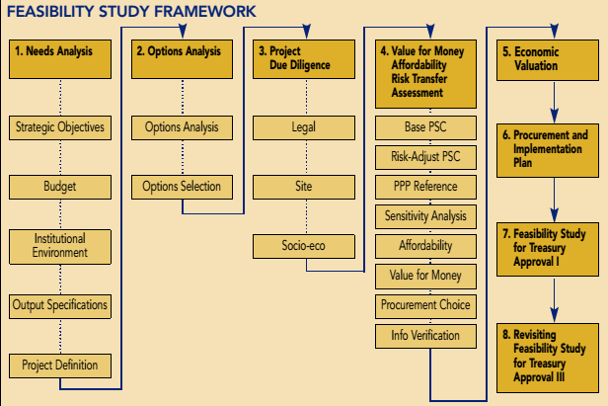

* The identification and prioritisation of **needs** is the first stage. Here, the government institution must clarify its objectives, find budgets for the required services and/or infrastructure, analyse institutional and stakeholder factors, and then specify the outputs that the project wants to achieve. Getting the output specification right is key. It requires that government decides what it wants to achieve, not how it wants to achieve it. These outputs are costed later in the feasibility study models and are cornerstones of the project.
* The options analysis stage enables the institution to explore a range of possible technical, legal and financial options for delivering the required service to the output specifications. A PPP is not itself an ‘option’ – rather, it may be a procurement choice for a preferred option. For example, a department needs a new head office. Its options may be three: to refurbish its existing building, or to rent another building, or to build a new one. The refurbishment and new build options could be achieved either by conventional procurement or via a PPP. However, the procurement choice is only made later in the feasibility study in the value-for-money assessment.
* A thorough due diligence undertaking is stage three, in which all legal, project site, socio-economic and black economic empowerment (BEE) matters are investigated by the government institution to uncover anything that may impact on the project.
* Stage four is pivotal in the feasibility study. It enables the metro to determine the best procurement choice for the project (PPP or other), using the three regulatory tests of affordability, value-for-money and risk transfer. PPP guidelines provides detailed guidance on how to construct these models, each of which must be risk-adjusted and calculated as a net present value. Risk is a central factor impacting on the value-for-money conclusions of this comparison, and a comprehensive risk matrix is required. Affordability remains the driving determinant of feasibility, and if this cannot be demonstrated, the institution must either adjust its output specifications or abandon the project. PPP types, BEE targets, project structure and sources of funding, and PPP payment mechanisms are all proposed at this stage.
* Once the procurement choice conclusions are reached and the information verified, the study can move to stage five, an economic valuation, using established micro-economic techniques.
* Stage six is the finalisation of a procurement and implementation plan that will demonstrate that the institution has the capacity and budget to undertake the project as envisaged.
* A final feasibility study report is then compiled for submission to Treasury in the prescribed format, ensuring that the case for the project is comprehensively argued and that conclusions are justified.

The feasibility study becomes government’s project handbook in every stage that follows its completion, enabling thorough procurement documents and draft contracts to be compiled, private sector bids to be evaluated against the feasibility benchmarks, negotiations to be conducted, and contracts to be managed.

If the project is procured as a PPP, the feasibility study is revisited as part of the final treasury approval prior to the signing of the PPP agreement with the private party. If at any stage during procurement or after the signing of a PPP agreement, the assumptions underlying the approved feasibility study are to be changed materially, the government institution is required to seek Treasury approval for such changes.

### Advantages of the PPP Structure

Though the working relationships between the public and private sectors are not new, the use of PPP structures is becoming increasingly popular. PPPs enable the participants to transfer the various risks inherent in a project to those who are best equipped to manage it. If a PPP is well structured it should enable all parties to better utilize resources by promoting efficiency and transparency, as well as provide a number of benefits including:

* Risk Diversification - The creation of an SPV enables the coming together of many different parties and facilitates the allocation and diversification of risk and financing requirements to more than one party. This diversification enables the undertaking of projects where the financial requirements or risks might be too great for any one party by itself.
* Risk Mitigation - The SPV facilitates the use of project financing which is intended to keep the specific risks of that project separate from the existing business of the private sponsors. This is beneficial in that the financial integrity of the project sponsor’s business will not be jeopardized should the project fail.
* Project financing - unlike traditional lending, is based on the financial strength of a project with little or no recourse back to the sponsor. The SPV borrows the funds and the debt is paid back using the cash flow generated from the project. Since it is the SPV that is borrowing the funds, this will not affect the sponsor’s credit rating and therefore not affect future borrowing by the project sponsor.
* Leverage – Leverage is the amount of debt in relation to the amount of equity used to finance a project. Projects financed using project-financing methods are usually highly leveraged in order to increase the equity return. The use of leverage can make projects more financially viable.
* Credit Ratings - Traditional corporate lending is based on the sponsor’s credit rating. Project financing facilitates the borrowing for a profitable project and is not restrained by the project sponsor’s borrowing limitations.
* Tax Benefits - Depending on the project, tax benefits sometimes exist for new enterprises. The establishment of an SPV to undertake a PPP can help sponsors take advantage of these tax saving mechanisms.

### Evaluation of 2016/17 Project Pipeline and Funding

The goal of this evaluation to determine whether the metro have developed appropriate strategies to find and select the right catalytic projects and developing a valuable project pipeline which are crucial to success. To be successful, the project identification, prioritisation and allocation process must be well defined and disciplined, addressing the most critical demands faced by the metro in a systematic way.

The key findings from the evaluation are summarised below:

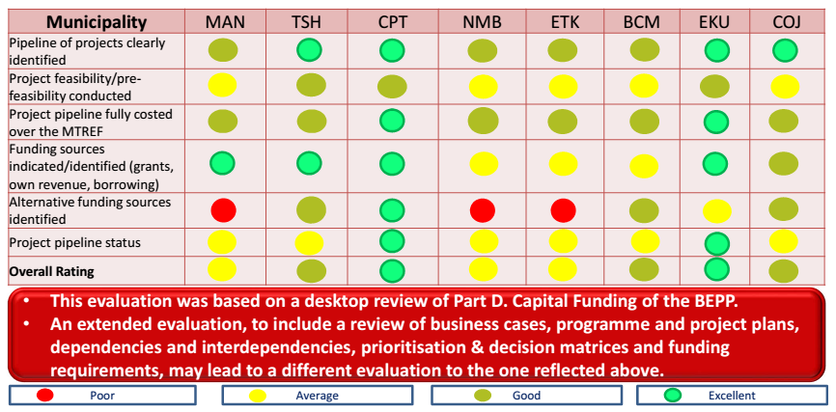

It is noted that the evaluation was based on a desktop review, and that apart from the inherent limitations from this approach, which was limited to Part D. Capital Funding of the BEPP. An extended evaluation which can include reviews of business cases, programmes and project plans, dependencies and interdependencies, prioritisation and decision matrices and funding requirements, may lead to a different evaluation from the one reflected above.

*The recommendations below must be interpreted with due consideration of the limitations of the current desktop evaluation. An extended evaluation may lead to a modification of the recommendations below.*

RECOMMENDATIONS – PROJECT PIPELINE AND FUNDING:

* It is recommended that BEPPs be standardised across all metros based on those of a high quality e.g. CPT.
* It is recommended that comprehensive detail be provided for all of the following components in Part D. Capital Funding of the BEPP:
  + Pipeline of projects
  + Indicate whether a project feasibility/pre-feasibility has been conducted
  + Project pipeline fully costed over the MTREF
  + Funding sources identified (grants, own revenue, borrowing) and status of financial closure in this respect
  + Identify alternative funding sources, and status of financial closure in this respect
  + Highlight projects for which funding has not been acquired/ secured
* Indicate next steps in respect of “unbanked” projects
* Indicate status of project pipeline

### Risks Identification and Mitigation

Large infrastructure projects suffer from significant under-management of risk in practically all stages of the value chain and throughout the life cycle of a project. In particular, poor risk assessment and risk allocation, for example, through contracts with the builders and financiers, early on in the concept and design phase lead to higher materialised risks and private-financing shortages later on.

Risk is also undermanaged in the later stages of infrastructure projects, destroying a significant share of their value. Crucially, project owners often fail to see that risks generated in one stage of the project can have a significant knock-on impact throughout its later stages.

The structuring and delivery of modern infrastructure projects is extremely complex. The long-term character of such projects requires a strategy that appropriately reflects the uncertainty and huge variety of risks they are exposed to over their life cycles. Infrastructure projects also involve a large number of different stakeholders entering the project life cycle at different stages with different roles, responsibilities, risk-management capabilities and risk-bearing capacities, and often conflicting interests. While the complexity of these projects requires division of roles and responsibilities among highly specialized players (such as contractors and operators), this leads to significant interface risks among the various stakeholders that materialize throughout the life cycle of the project, and these must be anticipated and managed from the outset.

And because infrastructure projects have become and will continue to become significantly larger and more complex, losses due to the cost of undermanaged risks will continue to increase. This will be exacerbated by an ongoing shortage of talent and experience—not only are projects more complex, but there are also more of them, which will create demand for more effective and more systematic approaches and solutions.

These risks include some or all of the following categories:

* Overestimating revenue and growth potential due to skewed incentives among project originators
* Sponsors and developers fail to plan delivery and stakeholder and project management in a sufficiently professional way
* Engineering and construction companies pay insufficient attention to mitigating and controlling risk during the design phase
* Financiers lack confidence in the ability of sponsors and other stakeholders to manage risks professionally and are not able to monitor developments and emerging risks themselves

Surprisingly, the risks of large infrastructure projects often do not get properly allocated to the parties that are the best “risk owners”—those that have a superior capability to absorb these risks. This can result from a misunderstanding or disregard on the part of governments of the risk appetite, for instance, of private investors who are sensitive to the kinds of risks they accept and under what terms. Providers of finance will often be the immediate losers from poorly allocated or undermanaged risks. Even in public-private-partnership (PPP) structures, private-risk takers and their management techniques are introduced too late to the process to influence risk management and allocation, and therefore they cannot undo the mistakes already embedded in the projects. One crucial consequence is an increase in the cost of financing PPP projects and a greater need for sovereign guarantees or multilateral-agency support. In the end, however, society at large bears the costs of failures or overruns, not least in the form of missed or slowed growth.

Private sources of investment are becoming increasingly scarce. Banks have weak balance sheets and are under severe regulatory pressure to avoid or limit long-term structured finance. Many are either reducing or exiting their infrastructure-financing businesses. Other potential “natural owners,” such as pension funds and insurance companies, either have regulatory constraints or are still in the early stages of considering direct investments and building up the necessary expertise.

This helps to explain why the dominant financing solution to deliver infrastructure projects is through budget-financed public-procurement processes. It is striking to see that—in the absence of private-sector management techniques and private-sector risk takers—public-infrastructure sponsors seldom apply state-of-the-art risk- and project-management tools and techniques, despite the knock-on consequences of being seen to “lose” public money during a time of increasingly constrained public budgets.

In effect, a larger volume of riskier infrastructure projects, managed by public servants who lack of risk- and project-management skills and resources, seeks funding from a market with lower financial supply and a significantly lower risk appetite among providers of both public and private financing.

This is not to argue that the public sector lacks any risk-management capabilities. In fact, many public-sector processes are very sophisticated, but they are geared toward ensuring transparency itself and avoiding the reality or appearance of misconduct and do so at the expense of effectiveness, efficiency of the process itself, and operational and execution risk-management objectives. As a result, the seeds of many project failures are sown in the early stages of development, when a poorly designed project-delivery approach or ill-considered procurement decision can lead to delays, higher costs, and ultimately diminished returns.

A more comprehensive approach to risk management would address the key issues facing all parties and stakeholders involved in a project throughout its life cycle, including project originators and sponsors, that is, governments and public entities, tackling both perceived risk, and financing gaps. Good practices in project structuring and risk management can radically improve outcomes in big infrastructure projects. A comprehensive “through the life cycle” risk-management approach is required. There are significant benefits in implementing an effective risk-management capability.

The key steps in the risk management process are:

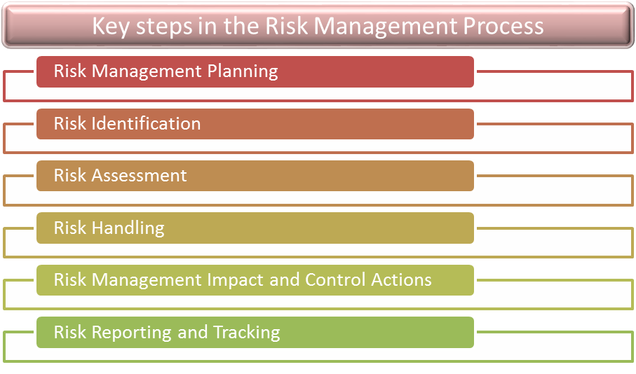

Good risk-informed project management requires the following:

* a comprehensive conceptual framework that introduces risk management across the value chain and highlights the most critical issues and design choices to be made;
* a strong set of practical approaches and tools that help governments and companies make these design choices and manage risks more proactively and thus more effectively; and
* an implementation framework that effectively introduces and ensures the application and execution of discipline in day-to-day business, starting in the beginning of the design phase all the way through the life cycle of a project

### Evaluation of 2016/17 Risk Identification and Mitigation

The evaluation sought to review the metros risk identification and mitigation plans related to capital infrastructure projects. Risk is inherent in all activities of any large scale infrastructure project. In order to be successful, a risk management process is needed such that risk can be continually evaluated and managed in order to minimise the consequences of adverse events.

The outcomes of the evaluation are summarised as follows:

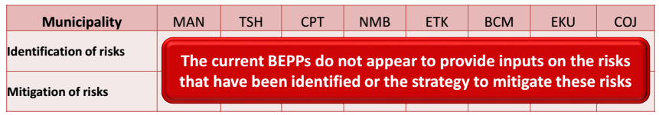

It was not possible to determine from the BEPPs whether metros have comprehensive risk management strategies and programmes.

RECOMMENDATIONS – RISK IDENTIFICATION AND MITIGATION:

* All metros should develop risk management strategies as a matter of urgency, with the following characteristics:
  + a comprehensive conceptual framework that introduces risk management across the value chain and highlights the most critical issues and design choices to be made;
  + a strong set of practical approaches and tools that will enable the metro to make these design choices and manage risks more proactively and thus more effectively;
  + an implementation framework that effectively introduces and ensures the application and execution of discipline in day-to-day business, starting in the beginning of the design phase all the way through the life cycle of the project
* High-level risks, as well as the mitigation plans, should be included in the BEPP, especially where this is of significance to a potential investor

### Conclusion

